JUMPING® INSTRUCTORS’ CERTIFICATION COURSE

By Jumping World Team

Registration Form
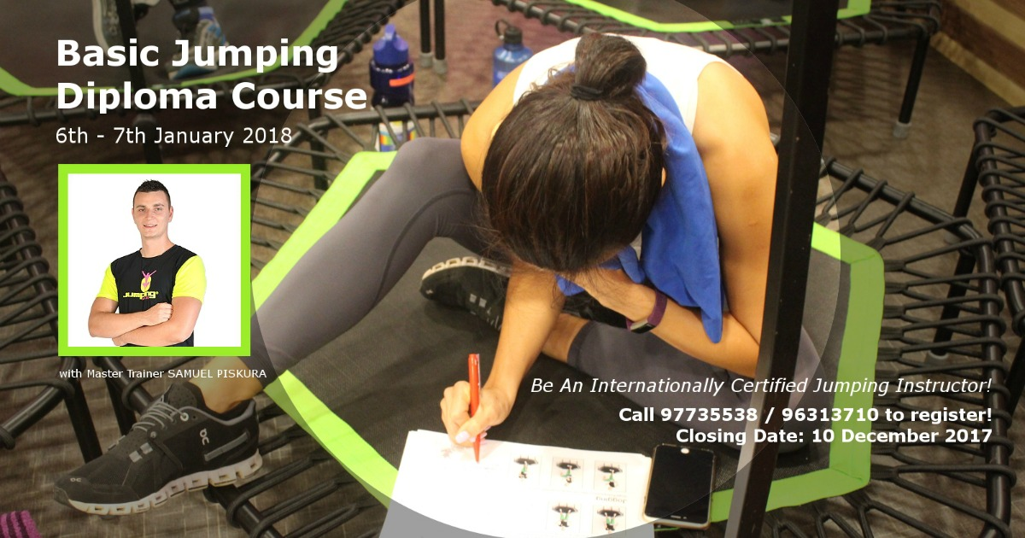

Course details:

Outline:
The jumping® instructor’s certification course is a theoretical and practical course that includes
- Movement Mechanics on the trampoline
- Static & dynamic stretching
- Strengthening exercises
- Communications,
- Terminology & relationship between music
- Balance & coordination

General Details:
Date : 6th-7th January 2018
Time : 9am – 5pm
Venue : Jumping@Peninsula
Peninsula Shopping Centre,
3, Coleman Street, #04-15
Singapore 179804
Master Trainer : Samuel Piskura, Jumping World Team, Czech Republic
Fee : $500
Contact : 96313710
Email : rosalind@newhopecs.org.sg

Payment Details:
You are required to pay $250 (50% of course fee) as deposit upon registration. You will be invoiced for the balance of $250 after the registration closing date.
Kindly Make Payment to New Hope Community Services:
Swift Code: DBSSSGSG
Bank Code: 7171
Branch Code: 015 (Thomson)
Account No.: 015-900776-6
Account Type: Current Acct.

Please fill up the form below and return to Rosalind at rosalind@newhopecs.org.sg before the closing date on 8th Dec 2017.
Please refer to the appended size guide to choose your attire sizes

Registration Form

Name: Click or tap here to enter text.
Address: Click or tap here to enter text.
Country: Click or tap here to enter text.
Contact Number: Click or tap here to enter text.
Date of birth: Click or tap to enter a date.
Email: Click or tap here to enter text.
Gender: Choose an item.
Singlet Size: Choose an item.

Singlet | XS | S | M | L
1/2 chest circumference | 34 | 36 | 38 | 40
1/2 waist circumference | 30,5 | 32,5 | 34,5 | 36,5
1/2 lower hem circumference | 36,8 | 38,8 | 40,8 | 42,8
Singlet length from shoulder back piece | 61 | 63,5 | 66 | 68,5
The depth of the neckline | 16,5 | 17 | 17,4 | 17,8

